Entry Quiz _ Methods Section

Choose “Yes” if you think the extract belongs in the Methods Section and “No” if you don’t.

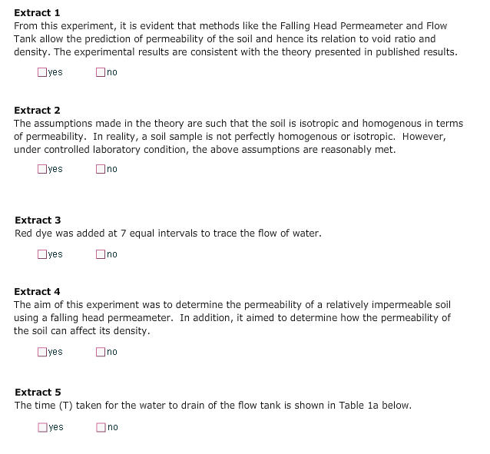

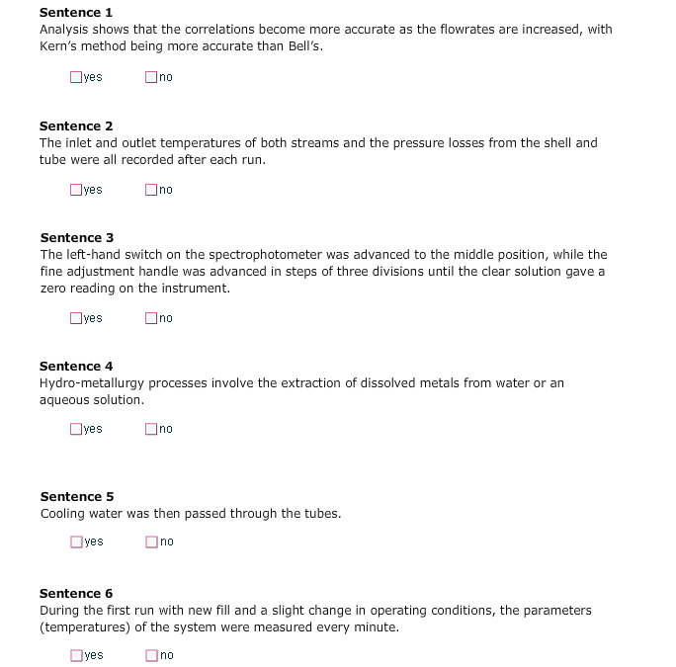

TASK: Only 5 of the sentences below can be put together appropriately to form a part of the Methods Section. Arrange them in the order they should appear. Discuss the result when you are ready.

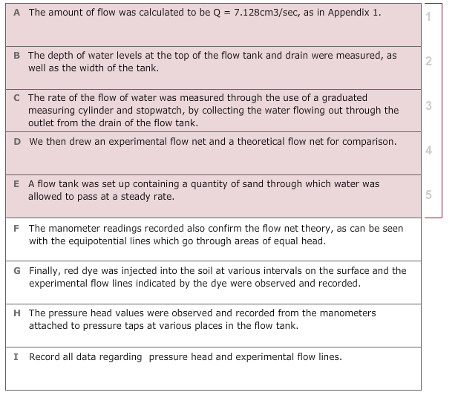

TASK: Only 3 of the sentences below can be put together appropriately to form a part of the Methods Section. Arrange them in the order they should appear. Discuss the result when you are ready.

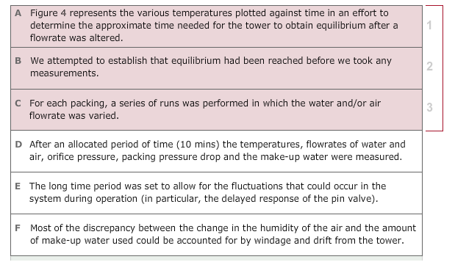

TASK: Read the example text on an experiment and then answer the questions.

